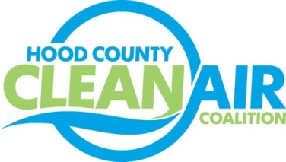
Meeting: Wednesday, November 4, 2015
Neely House
304 East Rucker Street, Granbury, Texas 76048
8:30-10:00 a.m.

Agenda

- Call Meeting to Order
- EPA Updates – Carrie Paige
- Regional Updates – Chris Klaus
  - Air Quality Funding Opportunities for Vehicles
  - Air Quality Technical Committee Meeting
  - Texas Regional Air Quality Conference Call
  - Texas Natural Gas Vehicle Grant Program Participating Dealer Training
  - DFW Clean Cities Annual Meeting
- Local Updates – Michelle McKenzie
  - Review of September and October Meeting Summary
  - Review of Projects
    - Monthly Budget Review for August
    - Status of Projects FY 14/15
      - Surrey Bikes
      - Propane Refueling Stations
    - Starting Projects FY 16/17
      - Technical Work
      - Administration – Office Lease Consideration
  - HCCAC Tax Exemption Consideration
  - Ozone Update through October
  - New Ozone Standard
5.) Discussion
6.) Adjourn

